PC37.68 Working Group on the
Guide for the Application of Electronic Controls to Pole Mounted and Padmounted Switch Gear
(October 15, 2007 Minutes)
- Introductions
Introductions were made by all in attendance. On-going roster was circulated.
- Minutes of last meeting – Corrections, approval
Minutes of the previous meeting were displayed for review and approved as submitted.
It was noted that the papers placed on the ftp site by Don Parker are still available.
- General Discussion
The IEEE set of patent slides were displayed for the group to read.
It was reported that Ken Workman has different responsibilities in his job. Don is not sure of his present status for participating in this group. John Angelis, responsible for the harmonics section, has changed companies and respectively requested to be excused from the committee.
Don Parker talked with a person from Whipp and Bourne about taking over the Harmonics sections. He will notify the group later. It was later pointed out that the harmonics had now been included with the other voltage transients per the index provided.
IEEE Roster Comments: All workgroup members need to make sure they are registered through myProjects. This requires being a member of the IEEE SA society to register. Don distributed a document detailing how to do this along with other files needed for today’s meeting by thumb drive during the meeting.
With the PAR this group is now called PC37.68.
Don Parker will talk with C37.60 to determine differences in wording about controls to avoid duplication of information between the documents.
The outline of the group was presented.
The PAR was displayed for the group. This PAR covers microprocessor controls. It does not cover the external transducers that feed it. There will be a challenge in the definition of the control because there is overlap between controls and relays. This group is creating a guide which will compliment existing standards. The guide will also cover the application of relays outside of the substation that is normally covered by the C37.90 relay standards. Don reviewed a drawing of this concept which is attached to these minutes. The relation between the control and device should take into consideration safety and functionality. We need to delineate software development to user functionality. Francois Soulard provided comments regarding this.
ACTION ITEM: Francois will summarize his comments for inclusion of these minutes later.
Functional requirements: Francois Soulard
Francois Soulard reported that he is presently researching military and NEMA specifications. These are not ready for reporting to the group yet.
Don Parker had a discussion with IEEE regarding surveys. He understood that the IEEE recently took a survey and compiled it in a four week period. Don feels that we may want to look into this to get more data with Francois’s survey.
ACTION ITEM: Don requested Francois to meet with IEEE staff at these meetings to determine if this is an option for us.
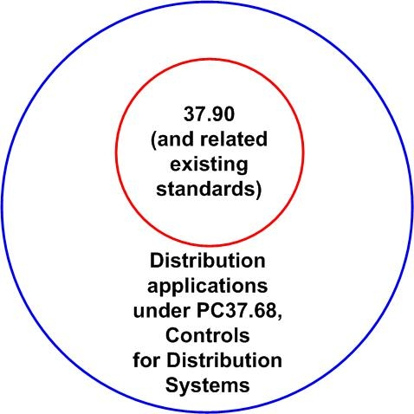
These meeting minutes were prepared and respectfully submitted by Frank DeCesaro.

